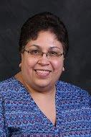
2024-2025 Education Support Professional Council
Chairperson  Jill Scarcelli (51) (2023-2026)  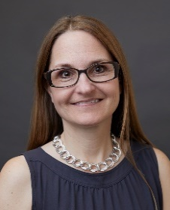  (C) 815-278-3287  Troy SD 30C  Library Associate  Time2read4fun@gmail.com | Vice-Chairperson  Debra Ward-Mitchell (27) (2023-2026)  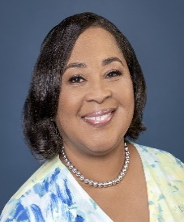  (C) 708-663-4024  Thornton Township  High School/SD 205  Paraprofessional  iteach4alvng@yahoo.com | ESP Council Member/Treasurer  Cheryl Jones (56) (2024-2027)  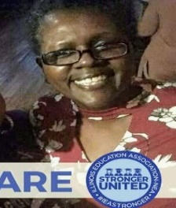  (C) 708-368-7751  Prairie Hills SD #144  Media Specialist  tovjoncher@yahoo.com
ESP Council Secretary/Member (nORTH central sectional rep)  Kristie Fidder (54) (2024-2025)  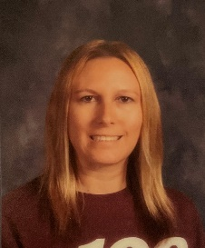  (C) 815-222-3110  Belvidere SD 100  Paraprofessional  kristie.fidder@gmail.com  North Central Regions: 15-25, 37, 38, 40, 44, 49, 51, 53, 54, 60, 61, 63, 65 and 66 | ESP Council Member (South central sectional rep)  Ray Greenberg (6) (2024-2027)  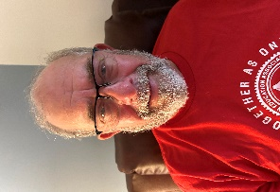  (C) 618-920-6523  Alton E. A.  Eunice Smith Elem.  School  raygreenberg@msn.com  South Central Regions 1-14, 45, 47, 48 and 62 | ESP Council Member (Suburban Sectional Rep)  Gina Lozano (34) (2023-2026)    (H) 847-612-9234  Timber Ridge School  Paraeducator  glozano@nsseo.org  Suburban Regions 26-36, 39, 41-43, 46, 50, 52, 55-59, 64 and 67
ESP Council Member (Ethnic Minority Rep)  Linda Matsumoto (41) (2022-2025)  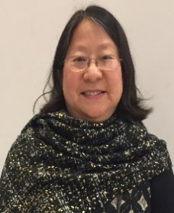  (C) 847-436-8101  Haven Middle School  Evanston/Skokie SD 65  Paraprofessional (Resource Educator)  p.r.marcomwhiz@gmail.com | ESP Council Member (Ethnic Minority Rep) INTERIM  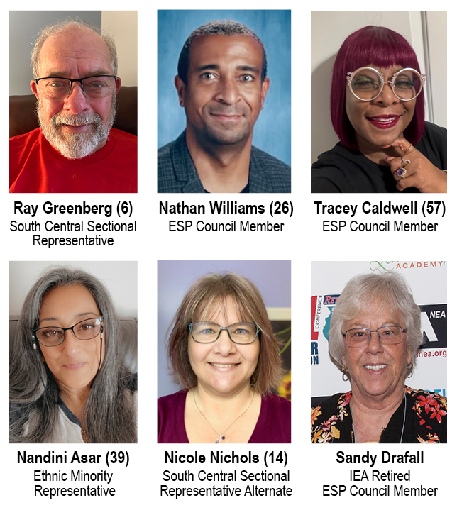  Nandini Asar (39) (2024-2025)  (C) 630-346-3239  Naperville North H.S.  Naperville SD 203  Financial Secretary  Dinirocks@gmail.com | Esp Council Member  Nathan Williams (26) (2024-2027)  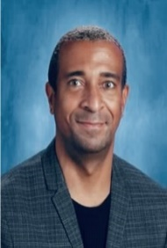  (C) 512-565-6721  Marya Yates Elementary School Elementary School District 159  williamsnathan2@gmail.com
Rev. 8.22.24
Esp Council Member  Tina Alexander (56) (2022-2025)  (C) 708-527-7159    Prairie-Hills  ESD 144  Registration/Transportation Coordinator  msblessed73@aol.com | Esp Council Member  Amanda Wood (39) (2023-2026)  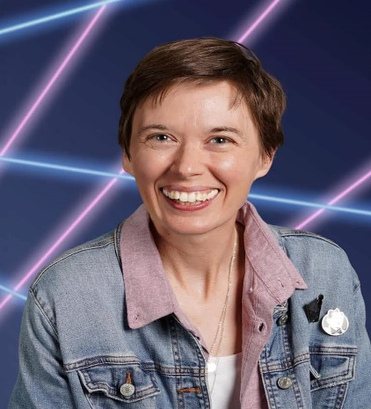  419 S. Hale Street  Wheaton, IL 60187  (C) 630-956-4408  Naperville SD 203  Health Technician  amandamaewood@gmail.com | Esp Council Member  Tracey Caldwell (57) (2024-2027)    (C) 708-351-7977  Media Specialist  Prairie Hills Jr. High  traycp46@gmail.com
Esp Council Member  Sandy Drafall (Retired) (2024-2027)  (C) 847-697-4585  Retired from School District U-46  Transportation Department in 2010  sandyjd68@gmail.com | North/Central Sectional Rep. Alternate  Sheri Konieczki (54) (2024-2025)  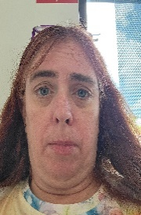  (C) 847-912-3521  Lincoln Elementary  Belvidere Consolidated SD 100  sher0816@hotmail.com  North Central Regions: 15-25, 37, 38, 40, 44, 49, 51, 53, 54, 60, 61, 63, 65 and 66 | Suburban Sectional Rep. Alternate  Julie Spaargaren (57) (2023-2026)    (C) 630 432 7060  School District 201  Paraeducator  jspaargare@gmail.com  Suburban Regions: 26-36, 39, 41-43, 46, 50, 52, 55-59, 64 and 67
South/Central Sectional Rep. Alternate (iNTERIM)  Nicole Nichols (14) (2024-2027)  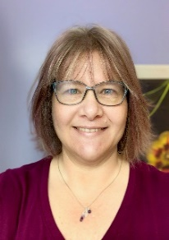  1-309-531-0202  Benjamin Elem.  McClean Co. Unit 5  Paraprofessional  NICOLE_N2@yahoo.com  South Central Regions: 1-14, 45, 47, 48 and 62 | IEA Esp Program Director  Cathy Wyzykowski  Staff Contact  2250 Point Boulevard, Suite 400  Elgin, IL 60123  (W) 847-428-7640  (C) 312-282-1549  cathy.wyzykowski@ieanea.org | IEA Esp PrograM  STAFF paraprofessional  Aedan Murphy  Staff Contact  2250 Point Boulevard, Suite 400  Elgin, IL 60123  (W)  aden.murphy@ieanea.org

Rev. 8.22.24

